**MPCA LAB WEEK-5**

**NAME : LAXMIKANT BHUJANG GURAV**

**SRN : PES1UG20CS658**

**ROLL NO.: 55**

**SECTION : K**

**DATE : 26-02-2022**

**PROGRAM 1 :** Write a program in ARM7TDMI-ISA to multiply 2 matrices of order3.

i.e., implement c[i][j]=c[i][j] + a[i][j] x b[i][j].

**a. Use MLA instruction :**

CODE :

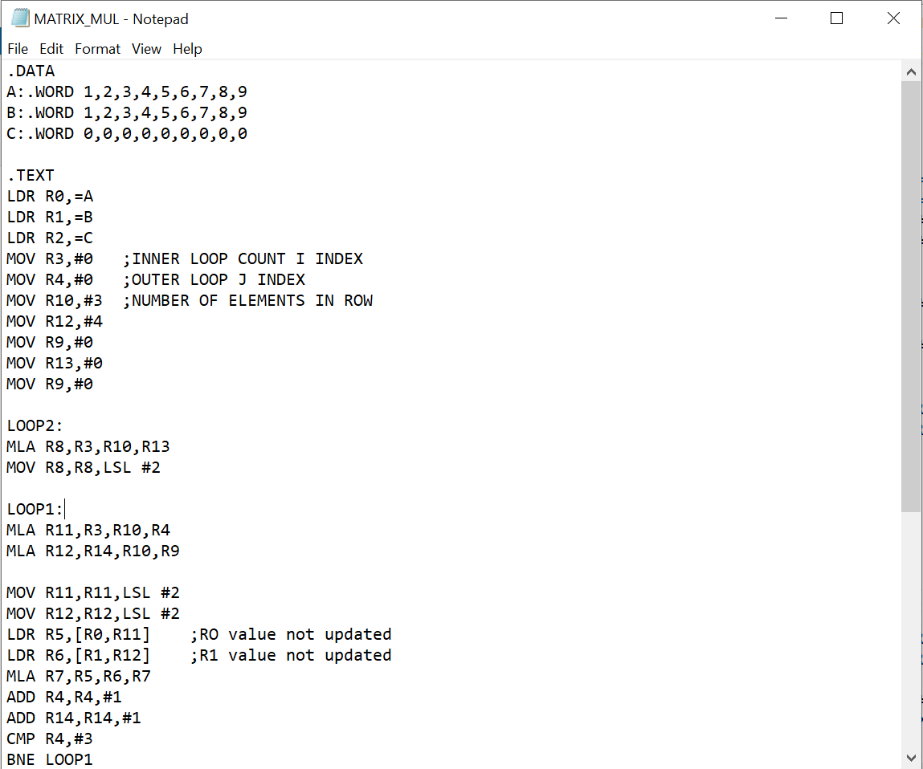 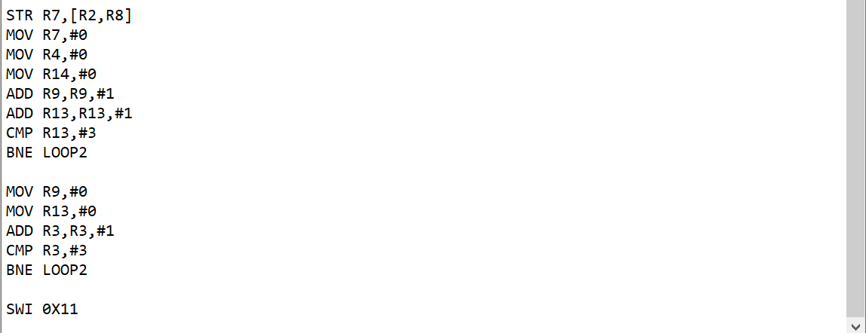

OUTPUT :

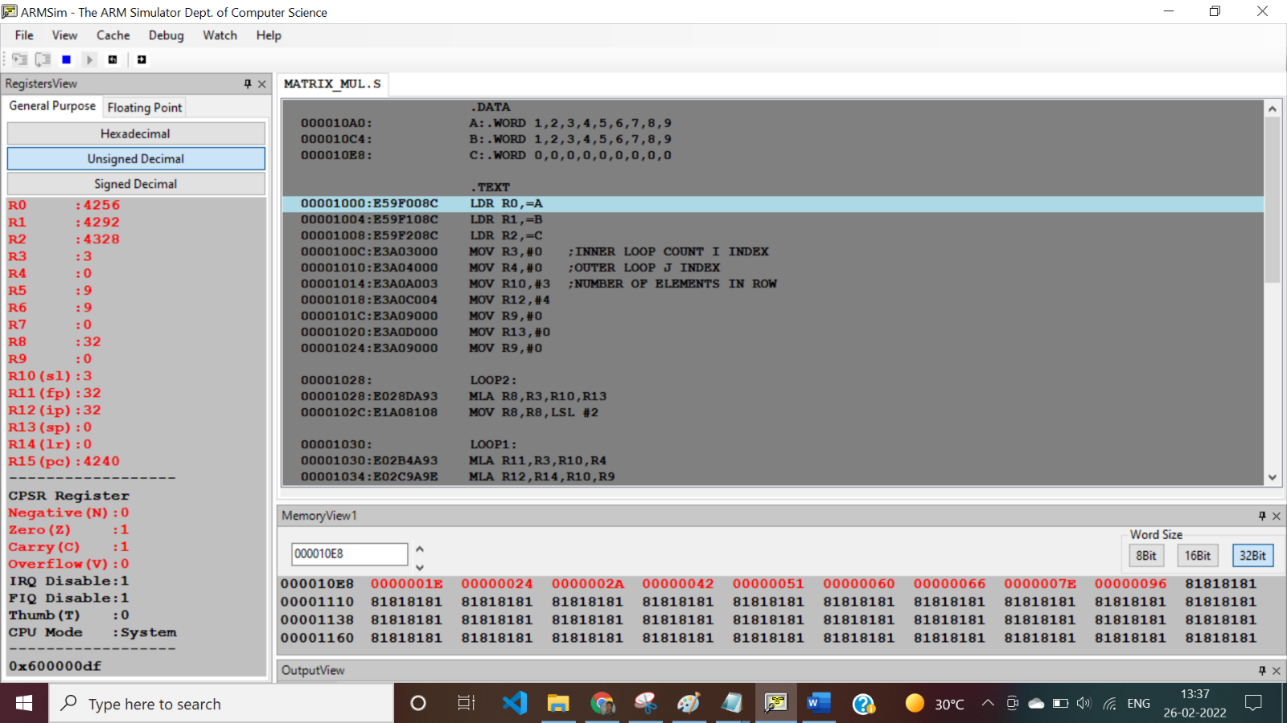

**b. Use MUL instruction :**

CODE :

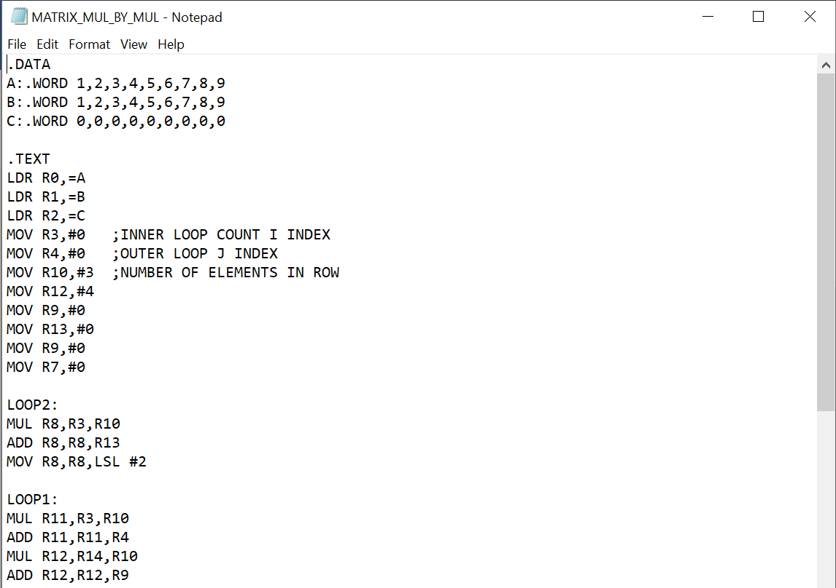 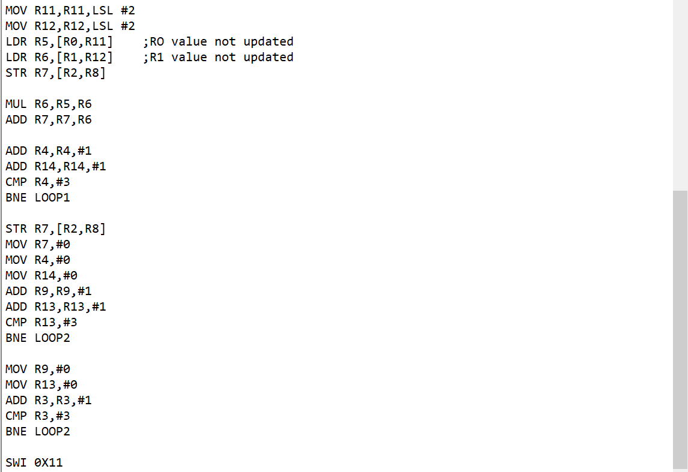

OUTPUT :

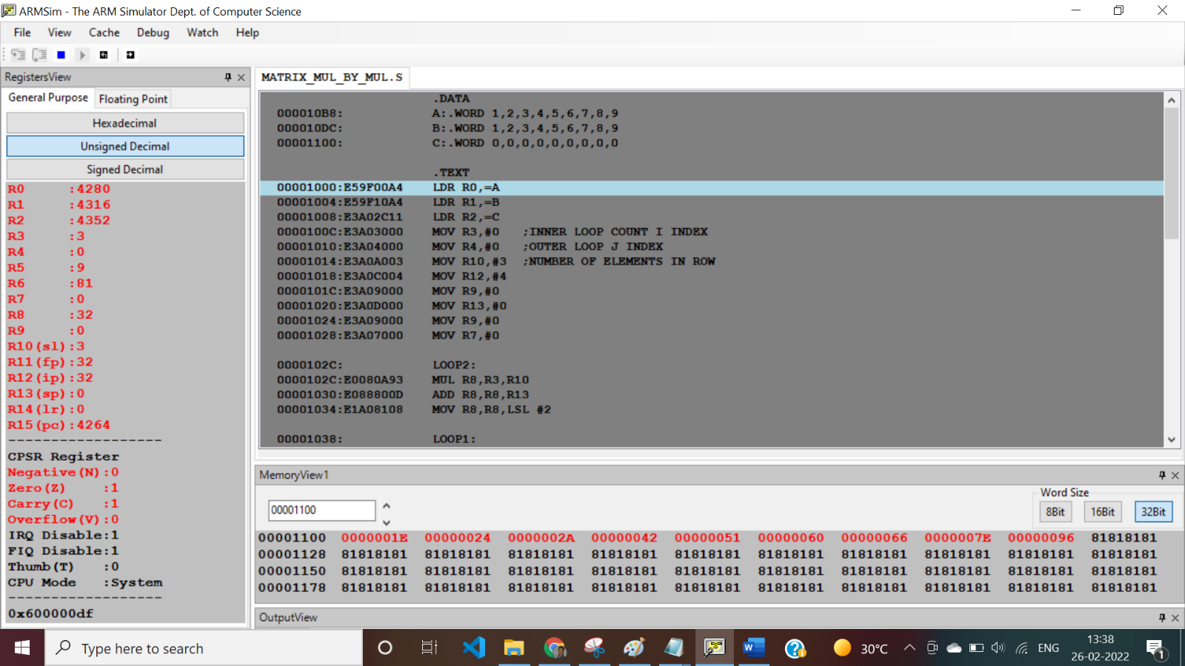

**PROGRAM 2 :** Write a program in ARM7TDMI-ISA to find the NORM of a square matrix of order n.

CODE : 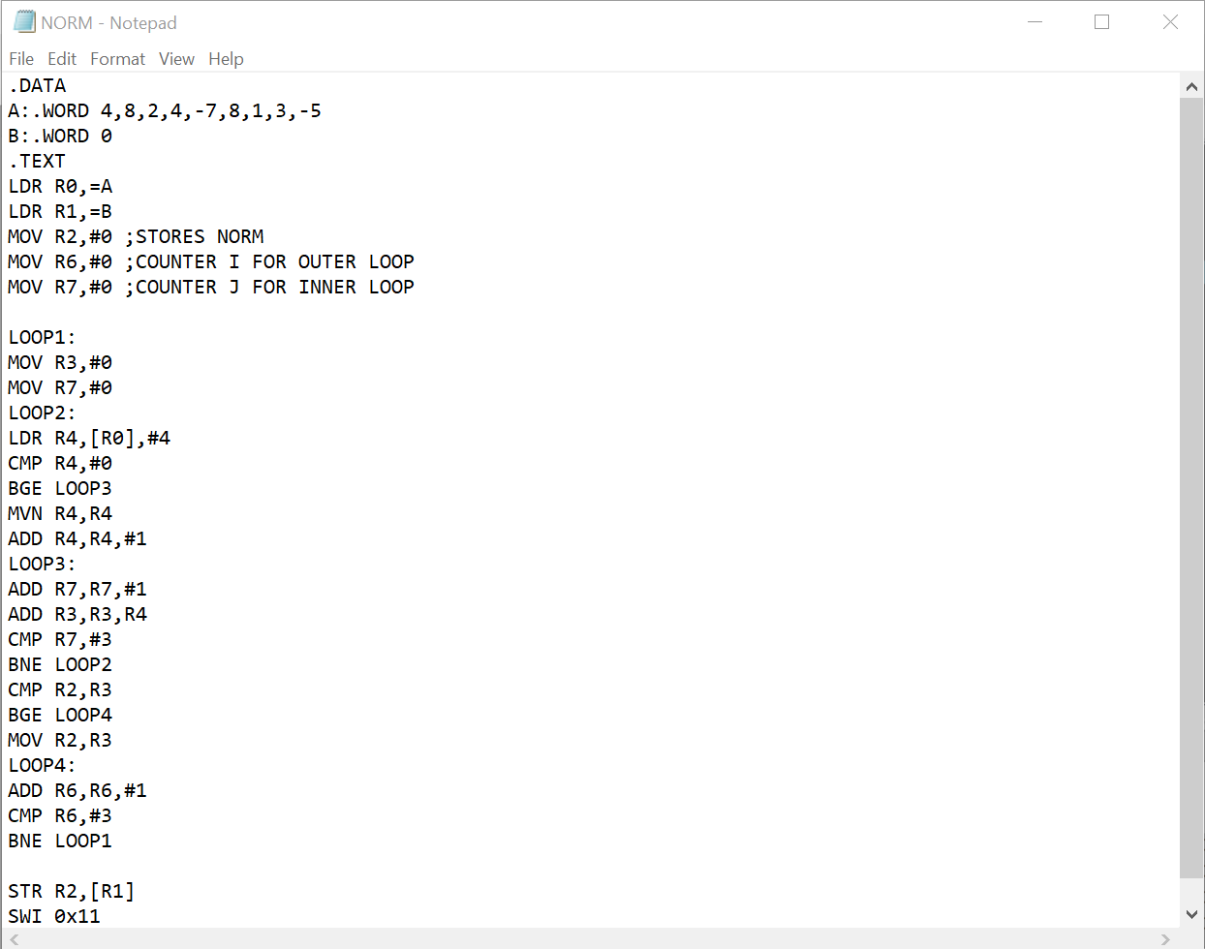

OUTPUT :

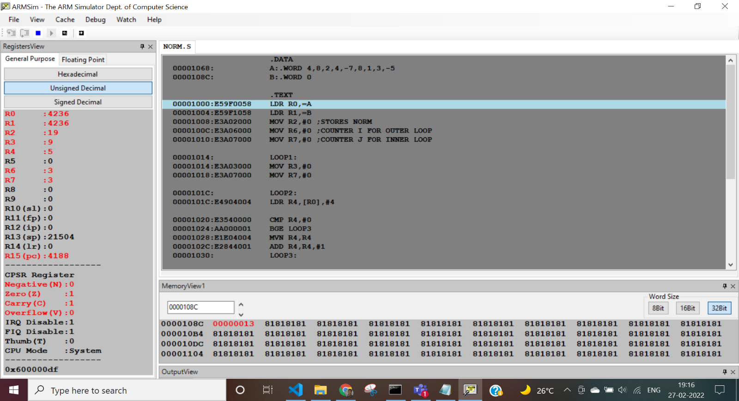

**PROGRAM 3 :** Write a program in ARM7TDMI-ISA to find the ROWSUM of a matrix.

CODE :

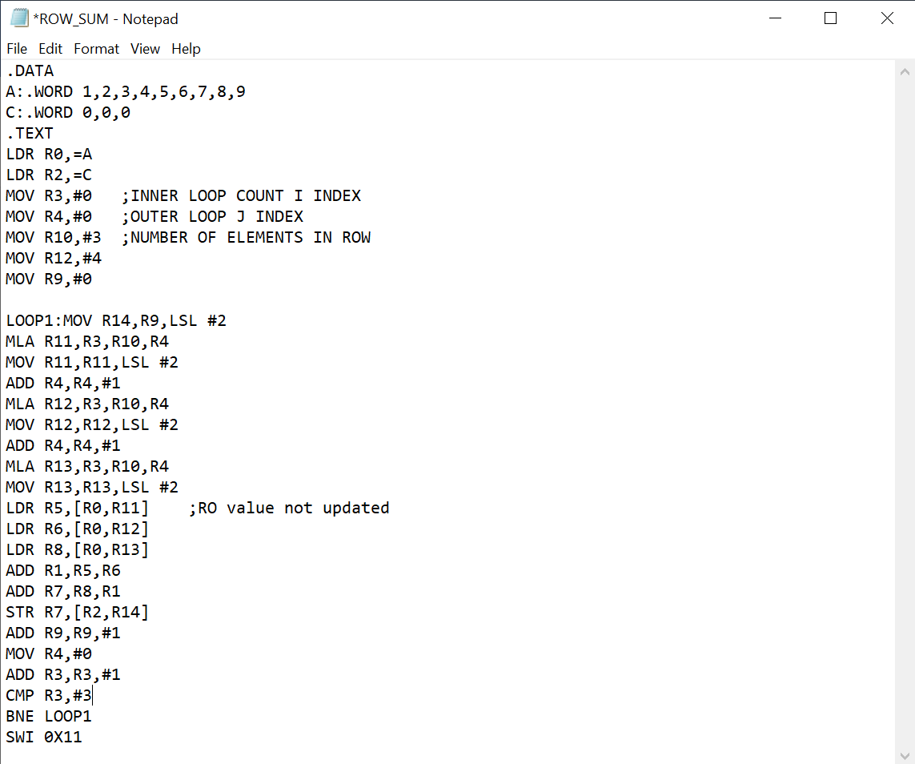

OUTPUT :

